South Melbourne Market - Expression of Interest
 | 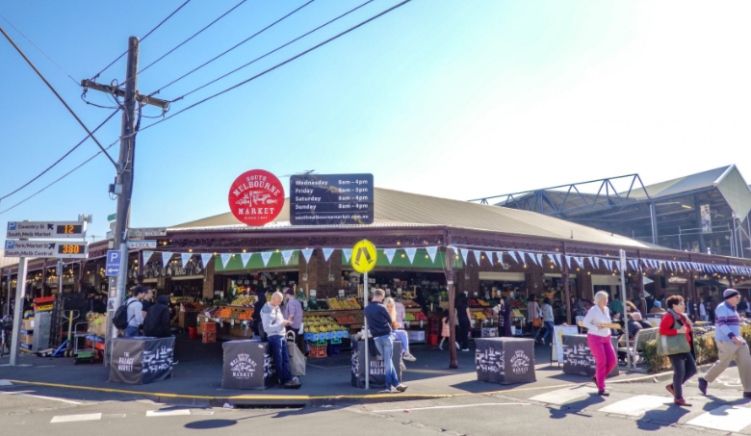
Business for Sale | Premium cornerstone site – Cecil and Coventry streets  Stall number – 53-55  Category – Food provedore/ Cook on site / Fresh  Trading Hours – up to 7 days  Licence Period – up to 10 years by negotiation.  Size: 123m² internal space; 42.8m² external yellow line area; 51.5m² cool room and back of house area. Footpath trading is in addition.  Please note that there is a purchase price for this business that will need to be negotiated with the seller.  Interested parties are invited to express their interest by submitting applications, supported by a business plan, which focus on the following objectives:  - Food Provedore, Hospitality, Food and Beverage  - Strong focus on a viable commercial operation  - Potential for community education and inclusion  - Visually interesting fit-out which responds to different times of the day/night and seasons. New fit out required.  - Complementary uses/operation with strong synergies to current market trading in linking precincts  - Potential for extended trading hours  - Best practice, creative and innovative business operations  - Environmental and social sustainability business strategies.  - A passion and connection with the SMM local community
South Melbourne Market | With over 5.5 million visitors annually, the South Melbourne Market has, and continues to, set the standard in placemaking which has delivered consistent growth in visitation over the past decade.  Since 1867, South Melbourne Market has been a treasured inner-city landmark and a favorite among locals and visitors. It is the quintessential village market, a place where people come not only to purchase fresh food, but to meet, eat, drink, shop, discover, share and connect.  Inside our Market, authentic traders display their wares with pride and passion. Quirky and playful characters are found behind the counters, delivering old fashioned customer service with a smile. We embrace and showcase the local, supporting local farmers, artisans, and producers.  It’s a foodie’s paradise where freshness, quality and diversity are paramount and foodstuffs from land and sea are on show. We celebrate a philosophy of real food, encouraging you to cook dishes made from great quality, fresh produce sourced from our family of traders you know, love and trust.  We are home to seriously good coffee, specialty tea and a vibrant restaurant precinct for day and nighttime activation. There is also an amazing array of merchandise and services with everything from clothing, homewares and secondhand books to hairdressing and pet food.  With a full calendar of live music, events and activities, the Market is a happy and experiential place that celebrates the senses. Take a trip to the Market: you never know what you will find, but we guarantee it will be full of surprising moments and experiences!  An independent committee, appointed by Council, governs the Market with support of the City of Port Phillip.  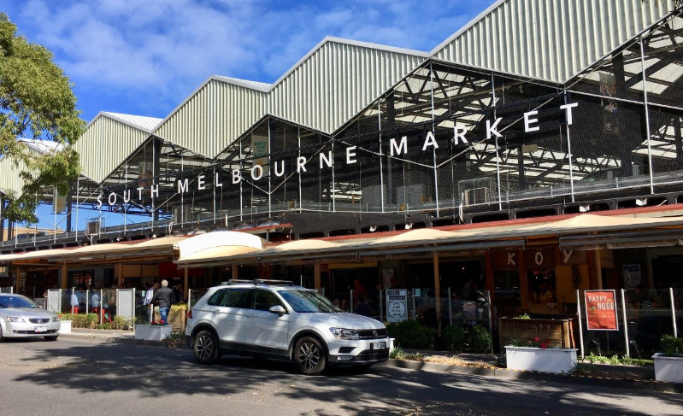
Precinct Overview  Cecil Street Dining / Coventry Street Fresh Produce | The South Melbourne Market is seeking expressions of interest for a new and exciting food concept to be the cornerstone tenant that links the Cecil Street Dining and the Coventry Street Fresh Produce precincts.  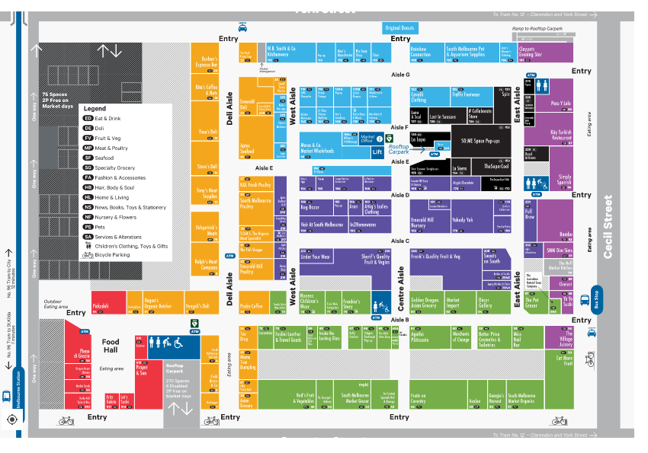  The Cecil Street Dining precinct is one of Melbourne’s best hospitality locations with daytime and nighttime activation across the 7 days of the week.  Features:  - High footfall  - Vibrant precinct with extended trading hours  - Day and nighttime economy  - Quality complementary concepts and operators  - Footpath cooking operation and seating with options for a liquor licence  - Weather protected outside areas  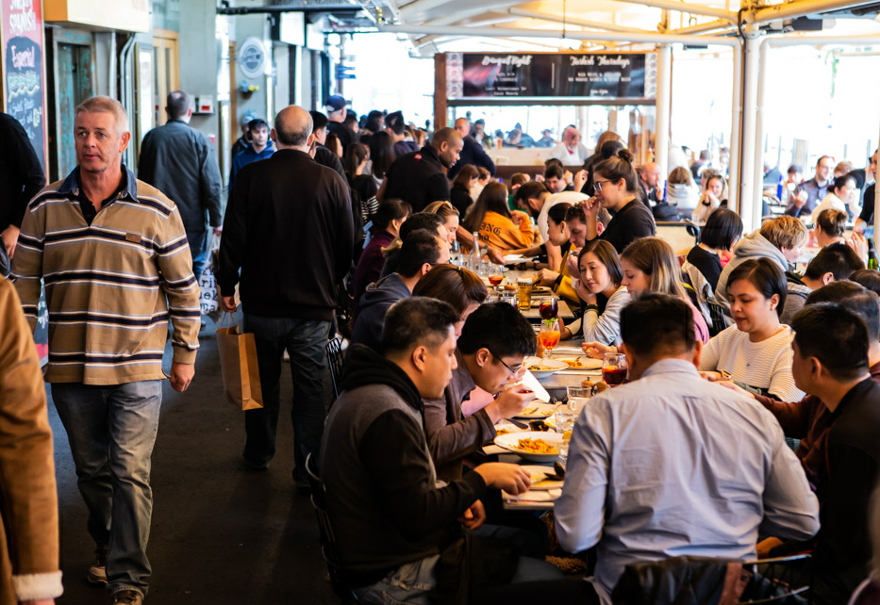
The Coventry Street Fresh Food precinct is a much-loved place for locals to shop for fresh produce and specialty items, supplying a wide variety of day to day essentials and niche delicacies.

    - High footfall
    - Vibrant local precinct
    - Quality complementary concepts and operators
    - Footpath trading

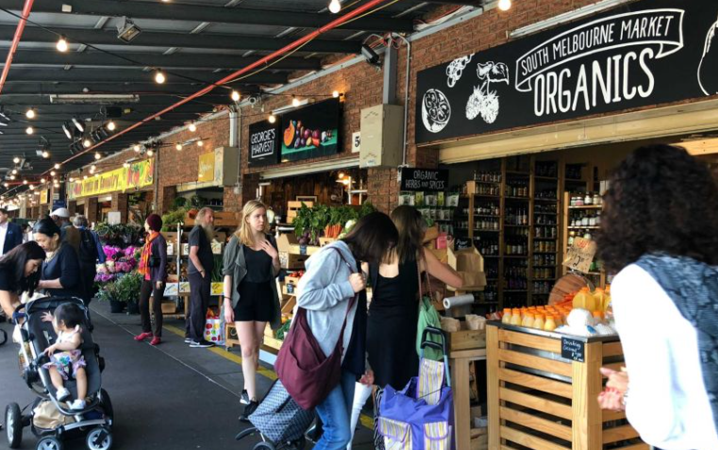

Licensing, Fees and Stall Details | Land Status - Crown Land. Council is the appointed Committee of Management under the provisions of the Crown Land (Reserves) Act 1978 and by further delegation to the SMMC, as a Special Committee of Council, pursuant to s.86 of the Local Government Act 1989.  Licence Term - Negotiable up to 10 years  Proposed Form of Agreement - SMM Licence  Fixtures and Fittings - Full dedicated fit-out is required. SMM will provide services required up to tenancy including ventilation if required  Services and Infrastructure - Electricity, Water  Size: 123m² internal space; 42.8m² external yellow line area; 51.5m² cool room and back of house area and upstairs office space. Ability to make use of footpath trading zone (kerbside) for seating or display, as per other stalls along Coventry St and Cecil St, subject to other infrastructure in that zone adjacent to Stall 53.  Rental Fees  Net Rental Offers should be submitted for consideration.  Estimated outgoings - The Licensee will be required to pay any metered charges for utilities such as gas, water, and electricity where applicable. The licensee will also be required to pay annual public liability, extraction duct cleaning and monthly pest control fee. On approval there is a Footpath trading fee which is paid to the CoPP.  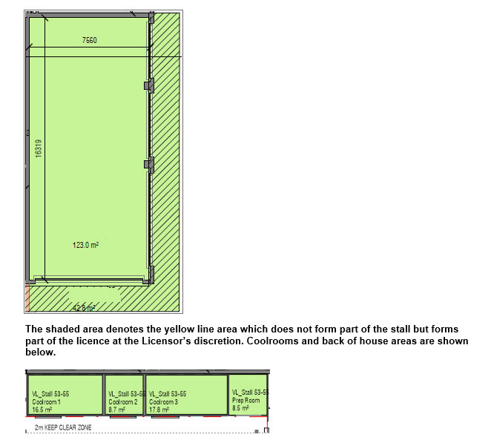
EOI Process | Pre-Application Recommendations:  - Review prospectus and application requirements  - Site visit/s  - Local competition analysis  - Discussions with SMM Management/ Licensing Team  - Clear understanding of SMM business sale process and transition of business  - Understanding of Market values and qualities.  More detailed information can be found at www.southmelbournemarket.com.au  Process:  The EOI process and trader selection will be conducted by SMM management and must be lodged via electronic submission.  Applications will receive an automated electronic response of submission.  - Applicants to read and understand all documentation  - Develop Business Plan – link to template is on the application page or develop your own addressing the information requested in the template  - Fill out and submit the application form online via SMM website  - EOI closes  - An evaluation panel comprising management team at SMM will evaluate EOI proposals based on evaluation criteria  - Applicants are shortlisted, and interviewed if required  - Successful applicant advised  - Business sale finalised between old and new tenant.  - Licence prepared and delivered
Contact | Victoria Niewalda on victoria.niewalda@portphillip.vic.gov.au  SOUTH MELBOURNE MARKET  Corner of Coventry & Cecil streets, South Melbourne, Victoria, Australia

