South Melbourne Market - Expression of Interest
 | 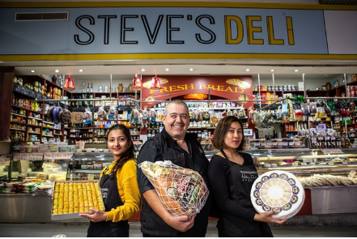
Business for Sale | Central Market Location – Deli Aisle (Steve’s Deli)  Stall number – 14 -15  Category – Speciality Fresh Food  Trading Hours – Currently 4 days – Wednesday, Friday, Sunday 7-4 / Friday 7-5.  Licence Period – up to 5 years by negotiation.  Size: 58.4m² internal space; and back of house area access via the Dock.  Please note that there is a purchase price for this business that will need to be negotiated with the current business owner.  Interested parties are invited to express their interest by submitting applications, supported by a business plan, which focus on the following objectives:  - Specialised Deli – with a point of difference to current offers.  - Strong focus on a viable commercial operation.  - New full fit out will be required.  - Complementary uses/operation with strong synergies to current market trading in Deli precinct.  - Potential for extended trading hours in the future.  - Best practice, creative and innovative business operations.  - Environmental and social sustainability business strategies.  - A passion for SMM  - A connection to the local community.
South Melbourne Market | With over 5.5 million visitors annually, the South Melbourne Market has, and continues to, set the standard in placemaking which has delivered consistent growth in visitation over the past decade.  Since 1867, South Melbourne Market has been a treasured inner-city landmark and a favorite among locals and visitors. It is the quintessential village market, a place where people come not only to purchase fresh food, but to meet, eat, drink, shop, discover, share, and connect.  Inside our Market, authentic traders display their wares with pride and passion. Quirky and playful characters are found behind the counters, delivering old fashioned customer service with a smile. We embrace and showcase the local, supporting local farmers, artisans, and producers.  It is a foodie’s paradise where freshness, quality and diversity are paramount and foodstuffs from land and sea are on show. We celebrate a philosophy of real food, encouraging you to cook dishes made from great quality, fresh produce sourced from our family of traders you know, love and trust.  We are home to seriously good coffee, specialty tea and a vibrant restaurant precinct for day and nighttime activation. There is also an amazing array of merchandise and services with everything from clothing, homewares and secondhand books to hairdressing and pet food.  With a full calendar of live music, events and activities, the Market is a happy and experiential place that celebrates the senses. Take a trip to the Market: you never know what you will find, but we guarantee it will be full of surprising moments and experiences!  An independent committee, appointed by Council, governs the Market with support of the City of Port Phillip.  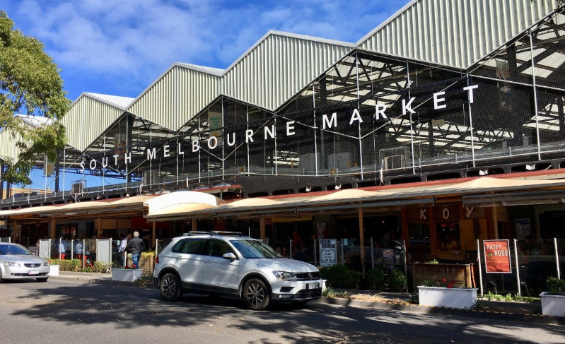
Precinct Overview  Deli Aisle | The South Melbourne Market is seeking expressions of interest for a new and exciting deli specialist concept to be a premium tenant that is centrally located in the busy Deli precinct. The location has a primary visual sigh line from Aisle E.  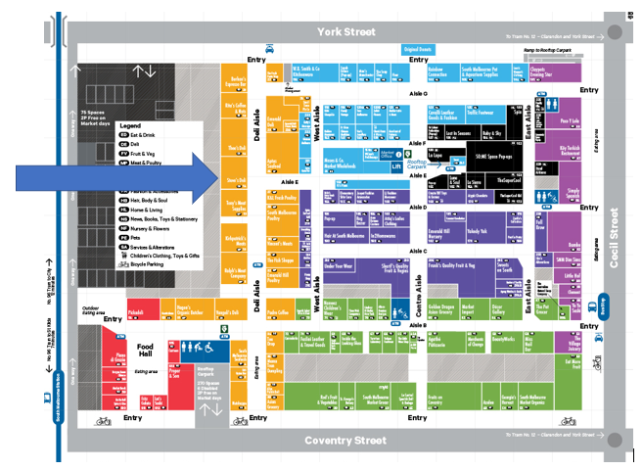  The SMM Deli Aisle Market precinct is one of Melbourne’s best specialty produce locations, known for its hustle and bustle, a mix of ingredient-based produce, fresh meat, poultry and seafood and a variety of deli offers. A market experience not to be missed!  In recent years SMM visitation in this area of the Market has grown by approximately 8% year on year (exception – 2020 - COVID) (orange highlighted area on map above)  Features:  - High footfall - total entry into the Market was 5,839,683 for this calendar year (2019), 63% of the visitation enter the site via the Deli Aisle.  - Approximately 3,685,021 people annually pass the tenancy, 63% of total visitation.  - Vibrant precinct with a universally recognised Foodie profile and loyal customer visitation.  - Quality complementary concepts and operators  - Central market location with main access to both Coventry and York streets.  - Direct Dock and loading / delivery access.

Licensing, Fees and Stall Details | Land Status - Crown Land. Council is the appointed Committee of Management under the provisions of the Crown Land (Reserves) Act 1978 and by further delegation to the SMMC, as a Special Committee of Council, pursuant to s.86 of the Local Government Act 1989.  Licence Term - Negotiable up to 5 years  Proposed Form of Agreement - SMM Licence  Permitted use – By negotiation with SMM management.  Fixtures and Fittings - Full dedicated fit-out is required.  Services and Infrastructure - Electricity, Water.  Tenancy Size: 58.4m² and back of house area access.  Rental Fees- Net rental offers (base rent plus %) to be submitted. Note current rent 2021-22 is $90,650.  Estimated outgoings - The Licensee will be required to pay any metered charges for utilities such as gas, water, and electricity where applicable. The licensee will also be required to pay annual public liability, Annual Public Liability fee: $684.00 (Inc GST) and monthly pest control fee of $70.75 per month (Inc GST).
 | 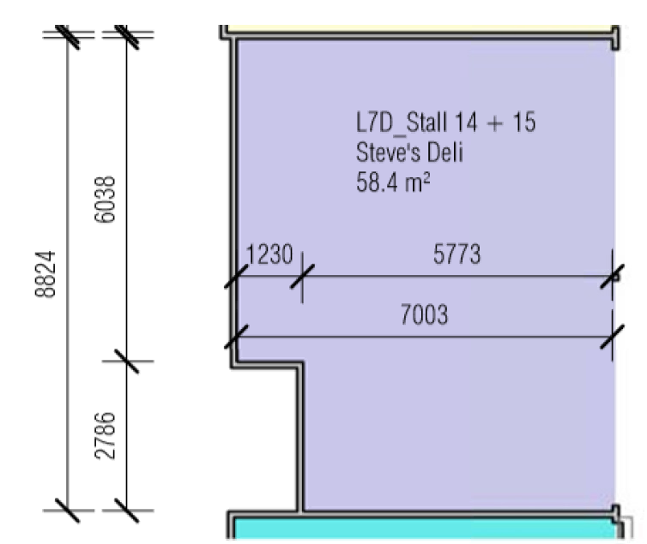
EOI Process | Pre-Application Recommendations:  - Review prospectus and application requirements  - Site visit/s  - Local competition analysis  - Discussions with SMM Management/ Licensing Team  - Clear understanding of SMM business sale process and transition of business  - Understanding of Market values and qualities.  More detailed information can be found at www.southmelbournemarket.com.au  Process:  The EOI process and trader selection will be conducted by SMM management and must be lodged via electronic submission.  Applications will receive an automated electronic response of submission.  - Applicants to read and understand all documentation.  - Develop Business Plan – link to template is on the application page or develop your own addressing the information requested in the template.  - Fill out and submit the application form online via SMM website.  - Fit out plans and concepts required.  - EOI closes.  - An evaluation panel comprising management team at SMM will evaluate EOI proposals based on evaluation criteria.  - Applicants are shortlisted and interviewed if required.  - Successful applicant advised.  - Business sale finalised between old and new tenant.  - Licence prepared and delivered
Contact | Victoria Niewalda on victoria.niewalda@portphillip.vic.gov.au  SOUTH MELBOURNE MARKET  Corner of Coventry & Cecil streets, South Melbourne, Victoria, Australia

