South Melbourne Market - Expression of Interest
 | 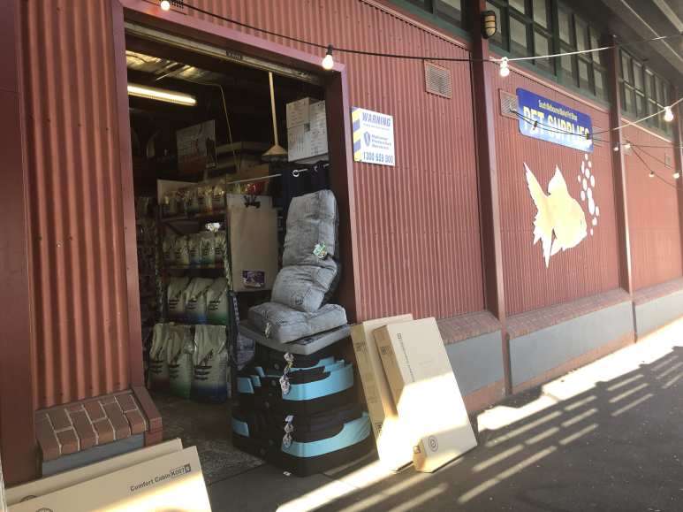
Business for Sale | Aisle G – York Street entry  Stall number – 105-107  Category – Pet Supplies  Trading Hours – Currently 4 days – Wednesday, Friday, Sunday 7-4 / Friday 7-5. External tenancy with availability to trade up to 7 days.  Licence Period – 2 years  Tenancy Size- 72.4m² internal space; double sided trading with access to York street and Aisle G. Plus 13.52 m2 of external display space. Opportunity for Footpath trading display.  Please note that there is a purchase price for this business that will need to be negotiated with the current business owner.  Interested parties are invited to express their interest by submitting applications, supported by a business plan, which focus on the following objectives:  - Pet Supplies with option to expand concept in the future.  - Strong focus on a viable commercial operation.  - Potential for extended trading hours.  - Best practice, creative and innovative business operations.  - Environmental and social sustainability business strategies.  - A passion for SMM  - A connection to the local community.
South Melbourne Market | With over 5.5 million visitors annually, the South Melbourne Market has, and continues to, set the standard in placemaking which has delivered consistent growth in visitation over the past decade.  Since 1867, South Melbourne Market has been a treasured inner-city landmark and a favorite among locals and visitors. It is the quintessential village market, a place where people come not only to purchase fresh food, but to meet, eat, drink, shop, discover, share, and connect.  Inside our Market, authentic traders display their wares with pride and passion. Quirky and playful characters are found behind the counters, delivering old fashioned customer service with a smile. We embrace and showcase the local, supporting local farmers, artisans, and producers.  It is a foodie’s paradise where freshness, quality and diversity are paramount and foodstuffs from land and sea are on show. We celebrate a philosophy of real food, encouraging you to cook dishes made from great quality, fresh produce sourced from our family of traders you know, love and trust.  We are home to seriously good coffee, specialty tea and a vibrant restaurant precinct for day and nighttime activation. There is also an amazing array of merchandise and services with everything from clothing, homewares and secondhand books to hairdressing and pet food.  With a full calendar of live music, events and activities, the Market is a happy and experiential place that celebrates the senses. Take a trip to the Market: you never know what you will find, but we guarantee it will be full of surprising moments and experiences!  An independent committee, appointed by Council, governs the Market with support of the City of Port Phillip.  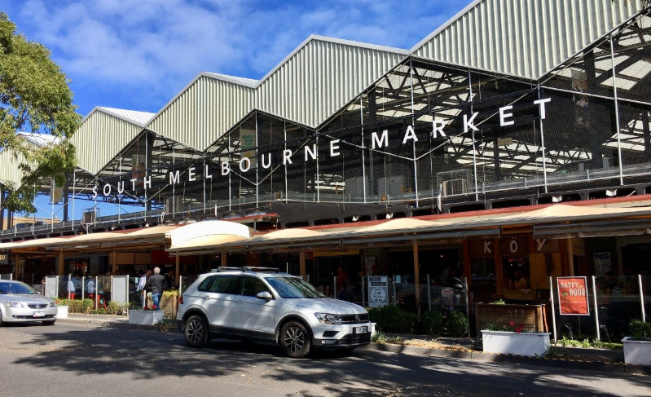
Precinct Overview and Location  Aisle G / York Street | 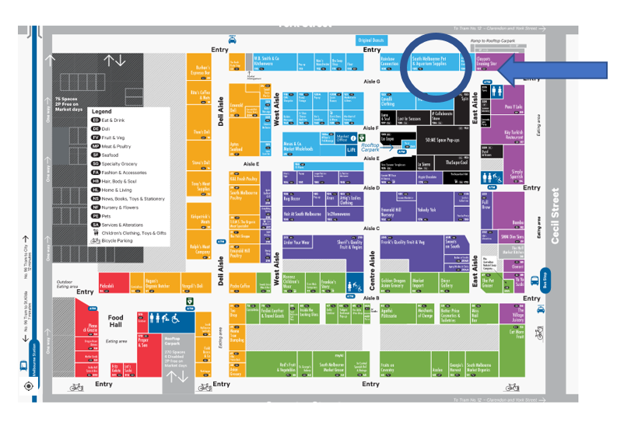  The SMM Aisle G / York Street precinct is full of quality operators, boasting specialty product, general merchandise and main entry points from both York and Cecil Streets.  Precinct features:  - High footfall - total entry into the Market was 5,839,683 for the calendar year (2019).  - Approximately 510,000 people annually pass the tenancy externally on York street and close to 750,000 enter Aisle G from Cecil Street.  - Quality complementary concepts and operators in a vibrant location of the Market.  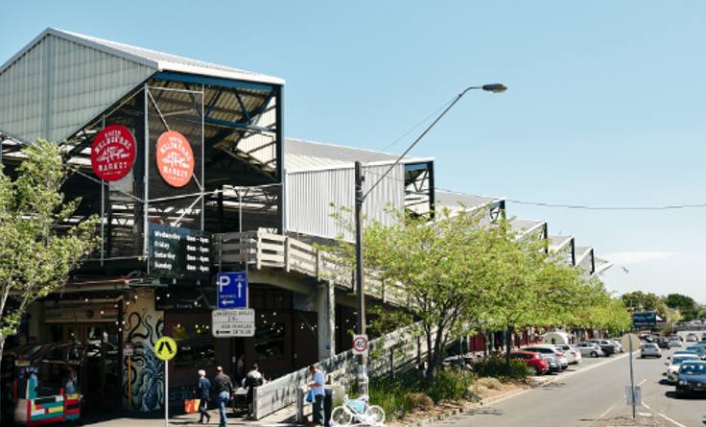

Licensing, Fees and Stall Details | Land Status - Crown Land. Council is the appointed Committee of Management under the provisions of the Crown Land (Reserves) Act 1978 and by further delegation to the SMMC, as a Special Committee of Council, pursuant to s.86 of the Local Government Act 1989.  Licence Term – Negotiable to 3 years  Proposed Form of Agreement - SMM Licence  Permitted use – By negotiation with SMM management.  Fixtures and Fittings – Visual Merchandising update is required.  Services and Infrastructure – Electricity, water.  Tenancy Size: 72.4m² and 13.57 m2 of display area.  Rental Fees-  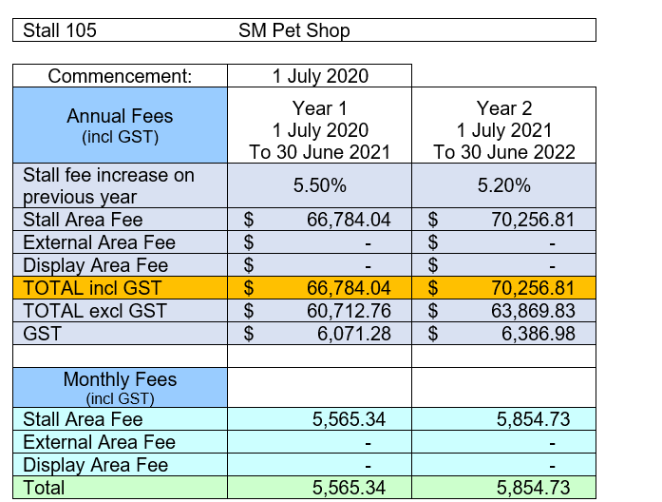  Estimated outgoings - The Licensee will be required to pay any metered charges for utilities such as gas, water, and electricity where applicable. The licensee will also be required to pay annual public liability fee 2021- $488.00 (Inc GST) and monthly pest control fee 2021 of $70.75 per month (Inc GST). Please note these fees may increase on a yearly basis.  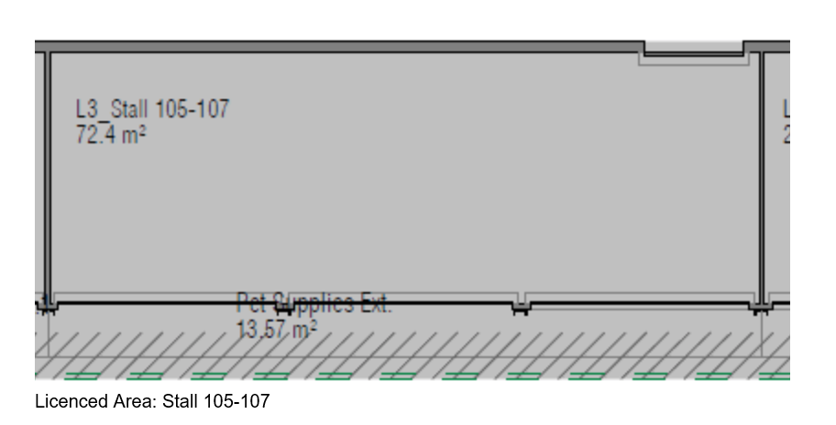
York Street Pet Shop External door to York St.
Market entry
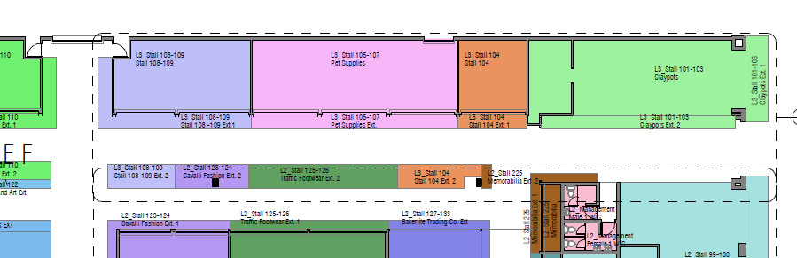

 | 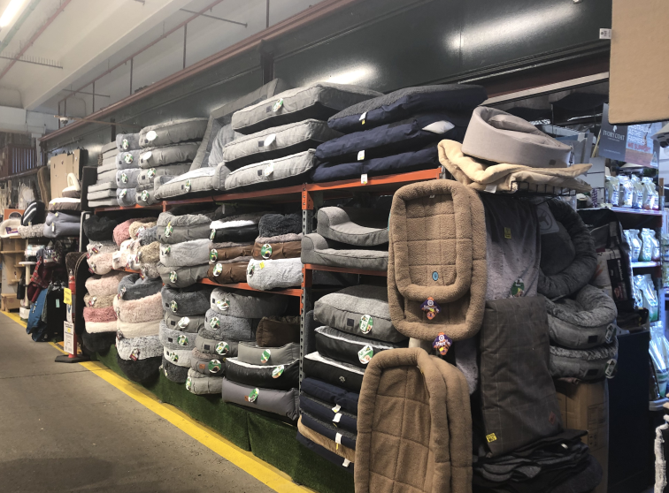
EOI Process | Pre-Application Recommendations:  - Review prospectus and application requirements  - Site visit/s  - Local competition analysis  - Discussions with SMM Management/ Licensing Team  - Clear understanding of SMM business sale process and transition of business  - Understanding of Market values and qualities.  More detailed information can be found at www.southmelbournemarket.com.au  Process:  The EOI process and trader selection will be conducted by SMM management and must be lodged via electronic submission.  Applications will receive an automated electronic response of submission.  - Applicants to read and understand all documentation.  - Develop Business Plan – link to template is on the application page or develop your own addressing the information requested in the template.  - Fill out and submit the application form online via SMM website.  - Fit out plans and concepts required.  - EOI closes.  - An evaluation panel comprising management team at SMM will evaluate EOI proposals based on evaluation criteria.  - Applicants are shortlisted and interviewed if required.  - Successful applicant advised.  - Business sale finalised between old and new tenant.  - Licence prepared and delivered
Contact | Victoria Niewalda on victoria.niewalda@portphillip.vic.gov.au  SOUTH MELBOURNE MARKET  Corner of Coventry & Cecil streets, South Melbourne, Victoria, Australia

